**Nature Weave**

**Grade: Pre-K – 3rd**

**National Visual Arts Standards:** VA: Cr2.1.PKa Use a variety of art-making tools; VA: Cr2.2PKa Share materials with others; VA: Re7.1.PKa Recognize art in one’s environment; VA: Re8.1.PKa Interpret art by identifying and describing subject matter; VA: Cn10.1.PKa Explore the world using descriptive and expressive words and art-making;

VA: Cn11.1.PKa Recognize that people make art.

**TS Gold Standards:** Objective 7: Uses fine-motor strength and coordination; Objective 8: Listens to and understands increasingly complex language; Objective 9: Uses language to express thoughts and needs; Objective 10: Uses appropriate conversational and other communication skills; Objective 11: Demonstrates positive approaches to learning; Objective 30: Shows basic understanding of people and how they live; Objective 31: Explores change related to familiar people or places; 33: Explores the visual arts.

**Early Learning & Development Standards:** AL4-4.1 Express unique ideas and approach tasks and experiences with flexibility and inventiveness; CC2-4.2 Describe specific elements of a piece of art, like position of objects included;

CC3-4.1 Experience, respond to and engage in a variety of dramatic performances; CC3-4.2 Role play to act out or play a character; CSS1-4.1 Describe events , activities, and people from the past using appropriate vocabulary; CSS1-4.2 Initiate conversation about familiar places, people, and/or events from the past; CSS3-4.5 With guidance and support, create a simple drawing that shows the relative location of specific objects/features in a familiar environment; LL1-4.2 Listen and respond attentively to conversation; LL1-4.4 Actively participate in creative dramatics; LL2-4.2 Use new vocabulary acquired through conversation and activities.

**Materials**: Image ofChitimacha baskets; cardboard, yarn, tape, assorted natural materials (pine needles, grass, leaves) scissors; basket

**Vocabulary:** Native American, weave, natural, weft

**Anticipatory Set 3 minutes**

Show students a basket or other woven object. Ask them if they can find a pattern. Choose one line and follow it around the basked. Why do people make baskets?

**Discussion: 10 minutes**

Show the image of the collection of Chitimacha baskets from NOMA and hold an open-ended discussion with questions such as:

* What are these?
* How do you think they were made?
* What patterns do you see?
* Where do you think the material came from?
* What colors can you see?
* What would you use this for?

Tell the class that the baskets were made by Native Americans here in Louisiana, and are from a group called the Chitimacha. Let the students say that word together outloud.

* Ask: *Why would they need something like this?*
* Ask: *Where do you think they got the materials to make these baskets?*

Tell the class the Chitimacha used river cane from the bayou in Lousiana and used berries and mud to dye the cane and make the black and red colors. The women in the group made the baskets.

**Introduce Art Activity 3 minutes**

Show the children the photos of the *Native American* pottery.

Tell them that just like in the song, long ago, Native Americans, who were a group of people who were known to be the first people in America. They lived off of the land and had to make the things they needed. These pots are an example of items the Native Americans made from the environment.

* Ask: *What do you think they are made of?*
* Ask: *Why do you think they needed baskets?*
* Ask: *Do you notice any decorations?*

Explain that they will make a piece of art (not a basket) that resembles the weaving practices of the Natives using *natural* materials, or natural found objects, which are things that come from the earth and are not manmade, and are used to make things needed in daily life. They may have used these *wefts*, of woven pieces of fabric, for clothing and blankets as well. By using natural materials in this activity however, you may explain that their work of art will not exactly be flat.

Say: *Today we are going to learn about the process of weaving. Like the Native Americans, we are going to use things that can be found in our environment.*

A weave (weaving) is a type of craft art in which you interlace threads, yarns, strands, or strips of some material to form, or make into a whole piece.

**Art Activity 20 minutes**

*This activity can be done as supervised center with small groups or as a whole group class activity.*

Each child will need: a pre-cut square or rectangular piece of cardboard (e.g. 5X8, 6X6), 2-feet of yarn, assorted natural materials.

* Step 1: *Build the Loom*: Take cardboard piece and cut 4-6 notches on the short ends.
* Step 2: *Tape the Yarn*: Tape one end of a piece of yarn to the back of the cardboard.
* Step 3: *Wind the Yarn*: Wind the yarn around the cardboard placing yarn in the notches, and then tape the other end to the back of the cardboard.
* Step 4: *Weave the Natural Objects*: Using the found natural materials, model how to weave pieces through the yarn (over and under, over and under) Allow students to try on their own.

*Step One* *Step Two*

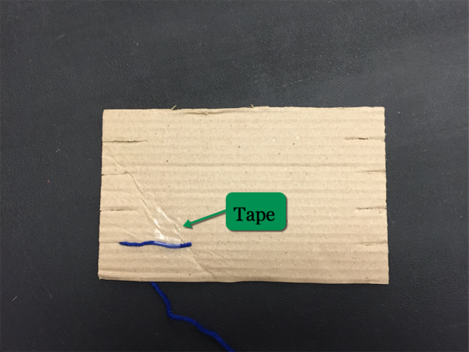

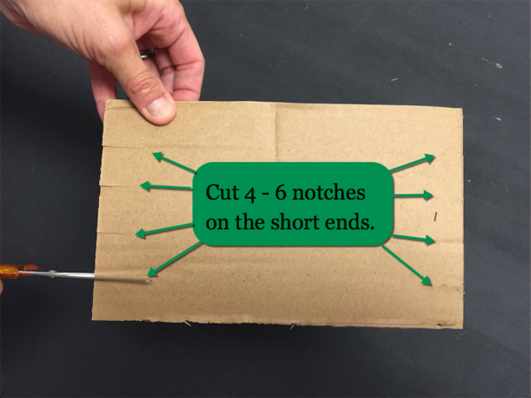

*Step Three* *Step Four*

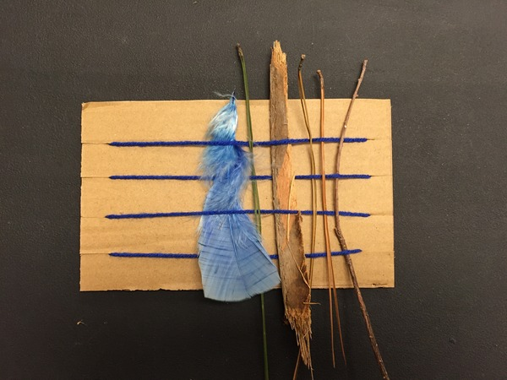

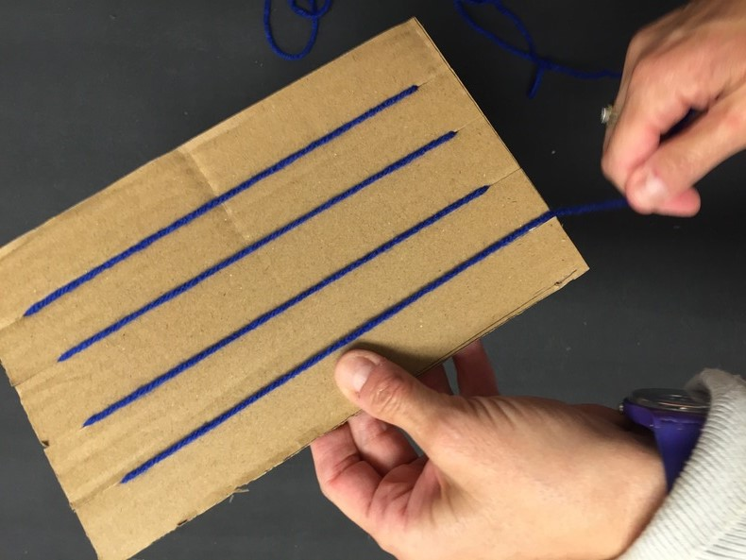

**Closing 5 minutes**

View the finished natural weaves together and ask several students to describe their work based on how used natural materials to create a work of art. Encourage them to use vocabulary words such as weave and weft. Review the vocabulary words once more and close by repeating the “Native Americans Song.” Congratulate the students for their efforts.