John Singer Sargent

John Singer Sargent was perhaps one of the greatest portrait painters of his time. Many people consider him an American Impressionist, but his work embodies many different qualities, making it difficult to categorize him. Sargent successfully assimilated different artistic techniques into his artwork to form a classical style of his own. He was born in Florence, Italy, on January 12, 1856 to American expatriates. The artist was one of six children. Three of his siblings died during childhood and he grew up the oldest child in the family. Although Sargent's parents were American, he did not see America until he was in his twenties.

Sargent's mother, Mary Newbold Singer, was married to FitzWilliam Sargent, a Pennsylvania doctor. After their wedding, Mary wanted to travel and experience Europe. She did not like the idea of remaining in one place for the rest of her life. She had inherited money from her father, making it possible for the family to travel. The inheritance did not make them rich, but it did sustain a comfortable, mobile existence.

The Sargent children were educated through their travels. Because the family moved so frequently, the children were not enrolled in a formal. By the age of eleven, Sargent was fluent in French and Italian and understood German. His mother encouraged his art education while his father became his tutor in other areas. Wherever the family traveled, Sargent recorded the images he saw in his sketchbooks. When he was eighteen, he began formal art studies, attending several art schools, as well as academic schools throughout Europe. When he and his father traveled to Paris in 1874, Sargent gained entrance to the École des Beaux-Arts, the most prestigious, traditional art academy in Paris. It was common practice for students at the École to study at independent ateliers, or workshops of established artists. Sargent worked at the atelier of Charles-Emile-August Durand, a fashionable artist at the time.

Durand, who preferred to be known as Carolus-Duran was an excellent yet eccentric teacher. He received many honors from the French government for his artistic achievements, portrayed in his unique handling of light and dark on the canvas. Duran wanted to move away from classic drawing; instead he used a method of working with half-tones. He did not see painting as an extension of drawing, but rather his method was to work from a tonal sketch to a finished portrait. Of all of Duran’s students, Sargent was most successful with this method. Carolus-Duran studied the Spanish master, Diego Velázquez and encouraged Sargent to study him as well. Sargent made a copy of Velázquez’s Las Meninas (The Maids of Honor), 1656, and found inspiration in Velázquez's compositions and use of light. Velázquez's work became a source of inspiration for both subject and in the way the artist handled the paint.

Sargent was rooted in his traditional Beaux-Arts training and was also influenced by the Impressionists working in Paris at that time. Sargent began incorporating the radical picture making devices of Monet such as plein-air painting and rapid brush strokes, but did not neglect the classical conventions he had studied. Although he used several aspects of the Impressionist style, he never fully incorporated the new techniques of painting atmosphere and light that the Impressionists developed.

After winning several awards for painting at the Salon, Sargent began painting in his own studio without the direction of a teacher. Sargent's painting of Madame Gautreau, a native of Louisiana living in France, is perhaps his most famous portrait. In 1883, due to Sargent's eager persistence, Madame Gautreau agreed to pose for the painting Madame X, 1884. The painting created a stir with it was was shown at the Salon. The controversy centered on the perceived indecency of the painting. The controversy preempted the artist’s move to London. Sargent continued to receive portrait commissions from wealthy and elite families of Europe and America, but his interest also in non-portrait subjects such as landscapes.
In the late 1890's Sargent began a series of portraits for the Wertheimer family. Asher Wertheimer was a London art dealer with discriminating taste. Mr. Wertheimer commissioned Sargent to paint pendant portraits of him and his wife for their 25th wedding anniversary. Eventually Sargent was hired to paint ten more portraits of his family. Upon finishing the Wertheimer portraits, the artist announced that he would no longer paint portraits and would instead concentrate on landscapes and moments in life. He did take a few commissions for portraits for a select few friends and rich, powerful industrialists. At the end of his career Sargent dedicated his time to the completion of the mural cycles which had been commissioned by the Boston Public Library.

John Singer Sargent died in London on April 14, 1925. The press praised him as one of the greatest portrait painters in the history of art. Sargent was a well-known artist and had a successful career. He did not pioneer a particular style, but showed the art world that an amalgamation of different styles and techniques could achieve beautiful and inspiring art.

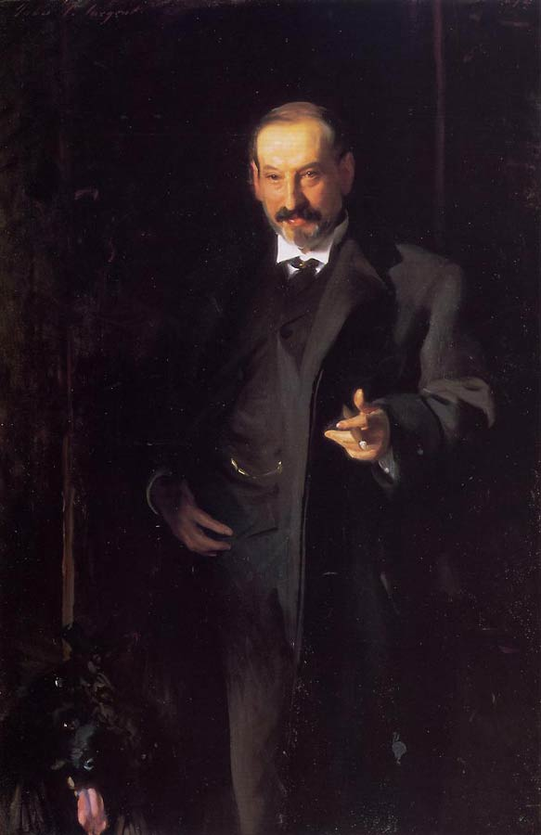
The Wertheimers

Before the late 19th century and the advent of photography, portraiture was a popular way for aristocrats to show their wealth. During the 19th century portraits also became popular with the nouveau riche. It is no surprise that someone with the wealth and prominence that Asher Wertheimer possessed would want his portrait executed by the greatest portrait painter of the Edwardian period.

Wertheimer was a successful art dealer in London. He and his brother, Charles Wertheimer inherited the business from their father Samson who had come as a Jewish émigré to England from Germany and built a successful business as a bronze maker and art dealer. When their father died, the brothers divided the business. Asher Wertheimer specialized in collecting and selling Old Master paintings and objets d'art, such as oriental porcelain.
John Singer Sargent (American, 1856 - 1925), Asher Wertheimer, 1898,
Oil on canvas, 58 x 38 ½ in.
The Tate Gallery, London

Wertheimer married Flora Joseph, the daughter of an antiques dealer. Together they had ten children, four sons and six daughters. The family lived in a wealthy London neighborhood in a house that was fashionably decorated.
In 1898 Asher Wertheimer commissioned the renowned artist, John Singer Sargent to paint two portraits, one of him and one of his wife to celebrate their silver wedding anniversary. Between 1898 and 1908, Wertheimer commissioned Sargent to paint 10 more portraits of the family. Mr. Wertheimer realized the importance of Sargent's work and is believed to have said that his only regret was there were not more Wertheimer children for Sargent to paint. It has been suggested that Wertheimer intended to donate the paintings to a museum, which would bring prestige to his family. Indeed, recognition of the family increased when six of the Sargent portraits were shown in London and Paris between 1898 and 1910.

A friendship was formed between Sargent and the Wertheimer family. The artist had resided with the Wertheimer family at their home in London and interacted with them socially. Sargent painted three of the Wertheimer daughters, Ena, Betty, and Almina, twice, both in group portraits and as individuals. The depiction of the women with humor and sensuality suggest that these were more than just models for the artist.

While they were in the possession of the Wertheimers, the paintings were displayed in the dining room and the morning room at Connought Place, the Wertheimer home. No artist before had been commissioned to do so many portraits for one family. In June 1916 Wertheimer announced his intention to bequeath nine of the portraits to the National Gallery of London. The works were to be exhibited together in one room of the museum. When Mrs. Wertheimer died in 1922, the paintings were presented. There was controversy surrounding this gift to the nation because of rising anti-Semitism. The status of the gift was debated in Parliament, but eventually the paintings were accepted. The portraits were exhibited together in the Tate Gallery of the National Museum of London.

Sargent's portraits of the Wertheimers marked the first time that a living artist's work was shown at the Tate Gallery. The paintings were displayed at the Gallery as Wertheimer intended them to be shown, as a group in a living room setting. The Tate Gallery still owns ten of the Wertheimer portraits as well as other works by this famed artist. The New Orleans Museum of Art owns the portrait of Mrs. Wertheimer commissioned for the twenty-fifth wedding anniversary and the National Museum of American Art owns a portrait of one of the Wertheimer daughters.
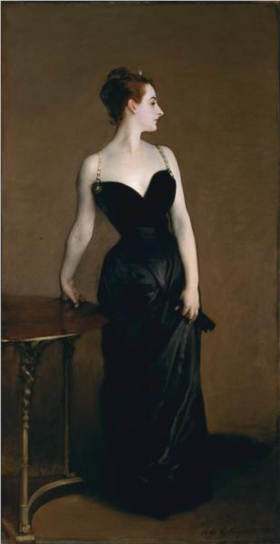

Madame X: Virginie Amélie Avegno Gautreau

“Her sole purpose in life is to demonstrate by her skills in contriving incredible outfits which shape her and exhibit her and which she can carry off with bravado. . . .”

Born in New Orleans, Ms. Gautreau had been brought to Paris as a child of eight by her widowed, socially ambitious mother. Her father, a major in the Confederate army, had been killed at the battle of Shiloh. She was, by 1883, twenty-four years old, two years younger than Sargent.

To her mother’s great approval, she had married a wealthy French banker, Pierre Gautreau, and became what was called a “professional beauty,” the perfect “parisienne,” someone known for her remarkable looks and social stage presence, and who, in her appearances in society, was expected to fill that role with all due attention to wardrobe and the artful use of cosmetics, no less than a great actress. In her particular case a heavy use of a chalky, lavender powder on face and body gave her a pallor distinctive enough in itself to draw attention. To her critics she was all too plainly an arriviste. Her beauty was distinctly different, almost eccentric, her nose too long by accepted standards, her forehead too high. Yet the total effect, and particularly given her hourglass figure and her way of moving, was striking in the extreme, her appeal unmistakably seductive, as she well knew.
John Singer Sargent (American, 1856 - 1925), Portrait of Madame X (Madame Pierre Gautreau), 1883 – 84),
Oil on canvas, 82 1/8 x 43 1/4in.
Metropolitan Museum of Art, New York

After meeting her socially, Sargent let it be known that he wanted to do “homage to her beauty” in a portrait to be shown at the Salon. He did one line drawing after another of her head in profile, made studies in pencil and watercolor of her relaxing on a settee in a low-cut evening dress, painted her in oil drinking a toast, and here again in profile.

In the winter of 1883–84, Sargent moved from the Left Bank to a new studio across the Seine at 41 Boulevard Berthier, in the then fashionable neighborhood near the Parc Monceau. It was there in a workplace elegantly furnished with comfortably upholstered chairs, Persian rugs, and drapery befitting his new professional standing, and an upright piano against one wall, that he painted his full-length portrait of Madame Gautreau, the whole time suffering what he called “a horrid state of anxiety.”
She was dressed in a long black satin skirt and low-cut black velvet bodice, her shoulders bare except for two slim jeweled straps. She held both shoulders back and her head cocked sharply to the left, giving full cameo emphasis to the remarkable profile. Her left arm on her hip, she held her skirt with the left hand, while the right arm was oddly turned back on itself, her right hand gripping the top of the side table. She wore her hair up, with a tiny diamond tiara on top. It was a flagrantly stagy pose, which could only have been difficult to hold for any length of time, even for one who was a poser by nature.

Against the deep black of the dress, the deathly blue-white of her powdered skin was even more strange and striking. When, during one sitting her right shoulder strap dropped suggestively over her arm, Sargent requested she leave it that way.

The 1884 Paris Salon, an exhibition filling thirty-one of the grandes salles in the Palais de l’Industrie, opened on a beautiful May morning with much excitement among the customary well-dressed crowds in attendance. So great had the number of American painters in Paris become, and so important to their careers was representation at the Salon, that they were now second only to the number of French artists included. For Sargent it marked the sixth consecutive year he had exhibited at the Salon, always with increasing acclaim.

Paintings filled every wall. The portrait of Amélie Gautreau, ideally placed at eye level, was hung in Salle 31, and the doors had been open scarcely an hour when it became the talk of the exhibition.
In an exhibition wherein paintings of nudes were commonplace, that of Madame Gautreau in her black evening dress was considered scandalously erotic. But what was unacceptable to “tout Paris” was the blatant, self-centered impropriety of it all—the heavy powder, the odd, arrogant pose, the décolletage. Such vulgar flaunting was simply not done by women of social standing.

Madame Gautreau and her mother came to the studio in tears. “All Paris mocks my daughter,” she said. If the painting were to stay on exhibit, she would “die of chagrin.” Sargent, obviously put out, told her there was nothing he could do, that it was against the rules of the Salon to retire a picture and that he had painted Amélie exactly as she was dressed.

The reviews were essentially of three kinds, those that objected to Madame Gautreau’s décolletage, those repulsed by the color of her skin, and those that, seeing “modernity” in the approach, applauded Sargent’s courage.

Sargent had been living and working in Paris for a full decade and in that time had received only expressions of admiration and praise. He had never known an adverse review or even mild criticism, let alone public mockery. His portrait of Madame Gautreau was in fact a masterpiece and in time would be so recognized. He hung on to it, renaming it Madame X. He also repainted the fallen shoulder strap, restoring it to its proper place. Years later, when he sold the painting to the Metropolitan Museum in New York he would remark that it was perhaps the best thing he had done.

He and Amélie Gautreau seem to have had no further contact, though she, too, eventually changed her opinion about the painting and expressed pride in it. Yet hard hit as he was and angry over what had happened, Sargent appears to have had no doubts about his ability or his ambition to keep painting. Feeling an immediate need for a change of scene, he followed up on an earlier plan to go to London. He left Paris in late May 1884, not to return until December.

Excerpted from The Greater Journey: Americans in Paris by David McCullough. Simon & Schuster. Copyright © 2011 by David McCullough.

