Native American Gallery (2nd floor)

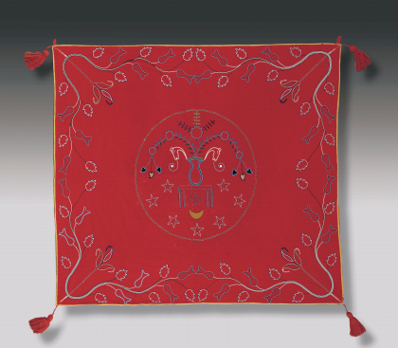
Chippewa Peoples, United States or Canada, Drum Cover, ca. 1880 Wool, glass beads, silk ribbon, wool yarn Promised Gift of Mercedes Whitecloud

The Dream Dance drum was considered a living, sacred being, addressed as “Our Grandfather,” which had to be guarded and cared for at all times. Hung from the ceiling or supported by sticks, the drum could not touch the ground directly and had to be covered when not in use. At the center of the cover is a circle that contains a complex design: a flower vase with fern-like plants rests on a table. Sprouting from the plants are five bulbous discs that appear to be peyote cactus buttons. (Peyote is a psychoactive plant used by the Native American Church.) Horses’ heads with song scrolls emerging from their mouths also arise from the vase. Around the table are eight five-pointed stars and a crescent moon, symbols used by the Native American Church.

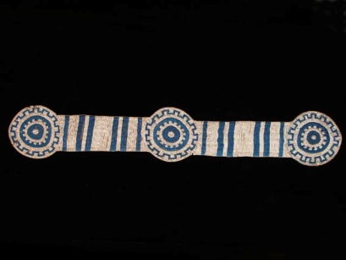
Plains Peoples, United States, Upper Missouri River Valley, Beaded Panel (Blanket Strip), ca. 1830 Glass beads, buffalo hide, sinew Museum purchase: The Brace Endowment Fund, 2011.69
Native Americans have lived on the Great Plains for thousands of years. Because of the extreme winters, the Northern Plains were sparsely settled. In the upper Missouri Valley region, groups like the Mandan and the Arikara built permanent dwellings of earth and wood that allowed them to endure the cold. Later, when Native Americans obtained the horse, large numbers began to move onto the Plains to hunt buffalo. In addition to the meat, which was consumed, the animal’s hide was used to make buffalo robes, an item necessary for surviving the harsh winters on the Northern Plains. The hairy side of the skin would be worn next to the body for maximum warmth. The inside of the skin would be treated, cleaned, and softened, and then decorated with paint or embellished with quills. In the early nineteenth century, glass beads from Venice were introduced, and although only a few colors were available they became a very popular means of embellishment. The blue and white pony-beaded panel at right is a “blanket strip” made to adorn the outside of a robe. Only four of these panels are known; this is the only one in a public collection.

Tlingit Peoples, Northwest Coast, United States or Canada, Chilkat Robe, ca. 1900 Mountain goat wool, cedar bark, native dye Gift of Mrs. Nellie W. Nolte. 52.0
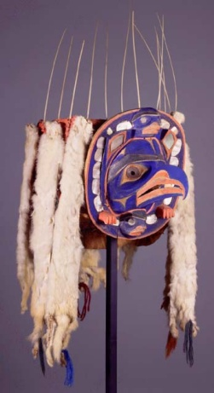
Nuxalt (Bella Coola) Peoples, Canada, British Columbia, Frontlet Headdress, late 19th century Wood, pigment, red haliotis shell, ermine pelts, woven cedar bark, sea lion whiskers, metal, mirror, yarn, printed cloth Gift of Adele and Carl Adatto, 79.345
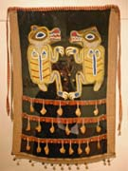
Kwakwaka’wakw (Kwakiutl) Peoples, Canada, British Columbia, Beaded Bear Apron, early 20th century Felt, printed cloth, glass beads, copper bells, puffin beaks Gift of Adele and Carl Adatto, 92.214

On this wall are objects, all created as dance regalia, from three nations of Native Peoples who live along the Northwest Coast of America and Canada. This Chilkat Robe is made of wild mountain goat wool. Split cedar bark was used to reinforce the yarn used for the warp. Men would paint the design on a cedar plank pattern board that was half the size and shape of the robe, and then women would weave the robe on a loom, repeating the design on each side. In the center is the crest emblem of the clan it was woven for; other images on the robe are stylized references to mythological animal beings connected to the clan’s origins. Dancing robes like this one were commissioned by wealthy chiefs. The Frontlet Headdress features a beautiful central motif of a bird-like being accompanied by two small human-like creatures, one on his head and one below the chin. The ovoid border is decorated with inlaid abalone, and the sea lion whiskers functioned to position eagle down feathers that the dancer would release into the air by thrusting his head back and forth. These dances would be performed at important events such as a potlatch, or gift-giving feast. Dancing regalia was designed to catch the firelight by adding materials such as abalone shell and strands of ermine fur.

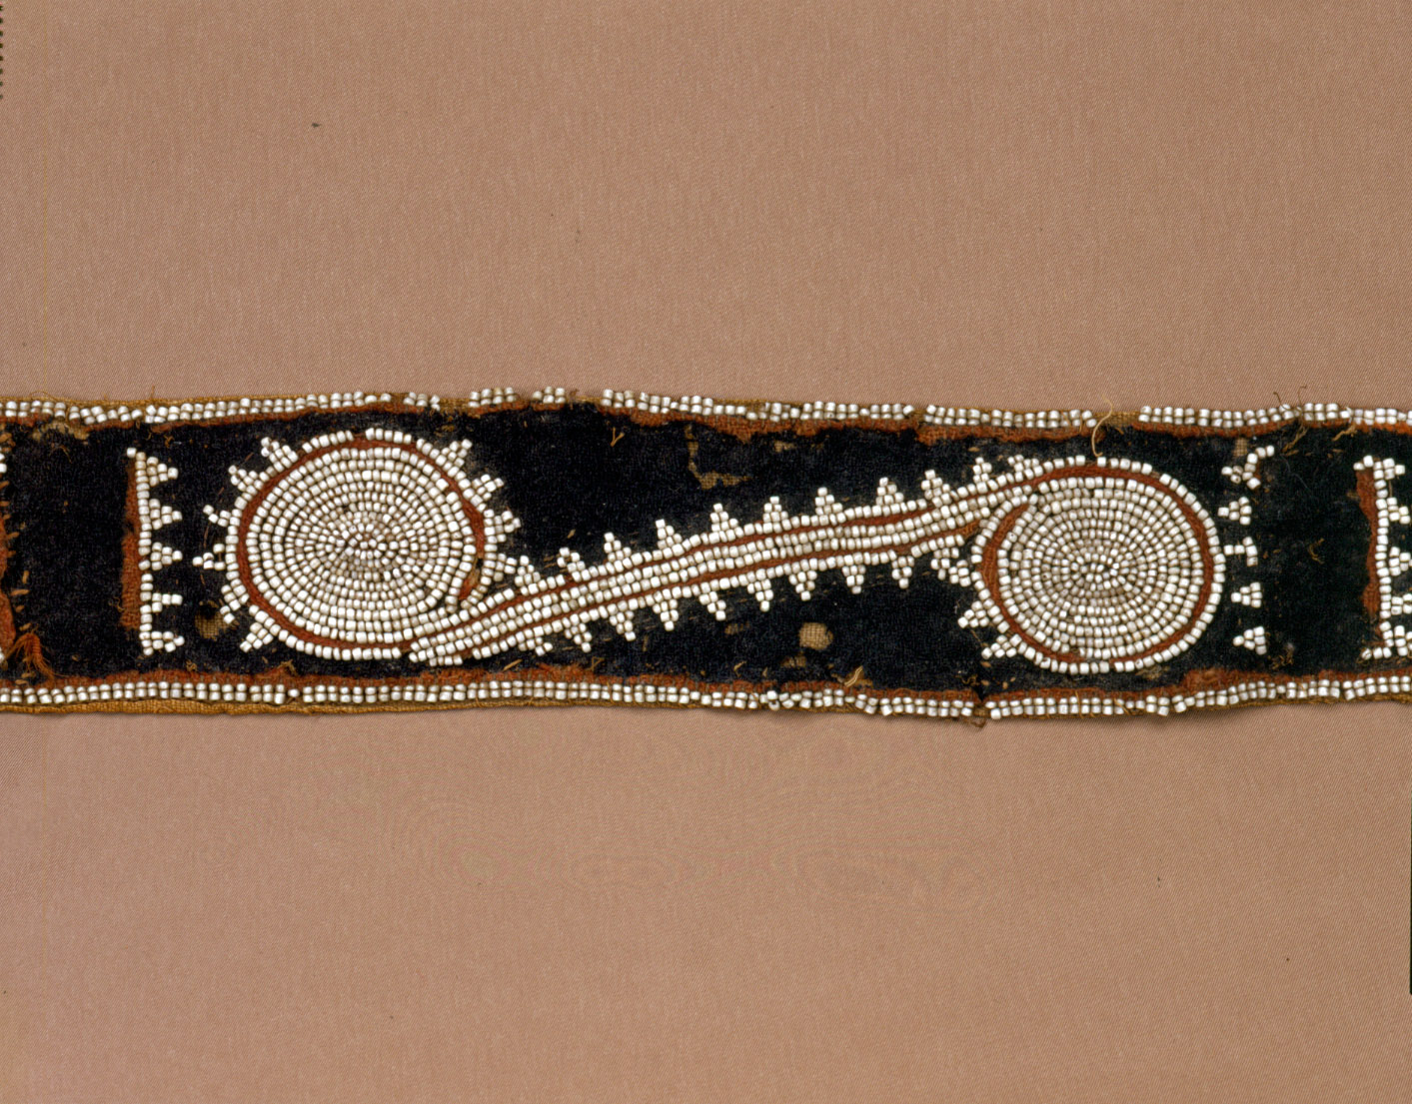Choctaw Peoples, Mississippi or Louisiana, United States, Beaded Sash, late 18th century Wool stroud, glass beads, linen, cotton, sinew Partial Gift of Mercedes Whitecloud in memory of Dr. Thomas St. Germain Whitecloud III, 2004.254
Mississippian Culture, Southeastern United States, Caddoan Style, Bottle, AD 1200-1500 Engraved terracotta Gift of anonymous donor in honor of Mercedes and Dr. Thomas St. Germain Whitcloud, 2007.2
Double spiral motifs such as these seen on the bottle, were frequently used to decorate prehistoric Mississippian engraved pottery, as well as conch shells and shell gorgets. The conjoined coils may refer to the conical spire of conch shells, which were valued among prehistoric Mississippian mound-building cultures as objects of trade and ceremony as well as drinking vessels and jewelry. By the middle 1500s, the Mississippian culture had collapsed due to the introduction of European diseases and the destructive campaign of Spanish conquistador Hernando de Soto. The Choctaw, indigenous to the Mississippi region, were likely descendants of the Mississippian mound-building culture that once populated the area. They seem to have adopted the spiral motif as an homage to the great culture of their ancestors and reserved its use for prestige objects.
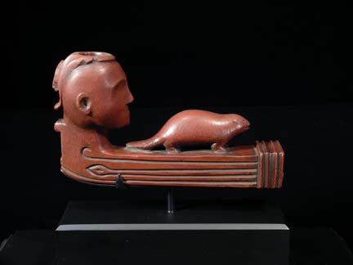
Chippewa Peoples, United States or Canada, Pipe Bowl with Human Head and Beaver, ca. 1820-25 Catlinite Promised Gift of Mercedes Whitecloud
Hopewell Culture, Indiana, United States (found in Dearborn County), Owl Effigy Platform Pipe, AD 1-400 Stone Loan from William Fagaly
Pipe making and smoking have been an important part of Native American spirituality for centuries. Here are two pipes, one made approximately 200 years ago and the other 1,700 years ago. Both were made by Native Americans living in the northern Woodlands, and both illustrate a tradition of decorating pipes with human and/or animal forms. The owl is revered because it can see in the dark and hunts at night. The Chippewa pipe pays homage to the beaver, an animal important to the tribe for its pelt, its meat and the fat in its tail. The bottom of the pipe is carved to represent the prow of a canoe. A figure sits in the canoe with a beaver. Carved on the side of the pipe is a spear and a hook, both used to hunt beavers.
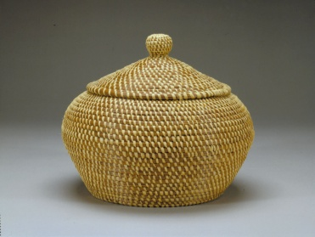
Liz John, Coushatta Peoples, Louisiana, United States Lidded Basket Jar, contemporary Pine needles, raffia Promised Gift of Mercedes Whitecloud, TMW(3)-26.a-.b
Liz John comes from a long line of Coushatta basket makers. The body of the basket jar resembles early pre-Columbian coiled pottery vessels of the Southeast. Here, instead of clay, Liz John has used bundled and coiled long leaf pine needles. To make the basket a practical and attractive storage jar, Liz John has woven a tight fitting knobbed lid that gracefully lifts the bulbous shape of the jar.

Janie Luster, Houma Peoples, Louisiana, United States, Basket with Handles, 1998-1999 Palmetto Promised Gift of Mercedes Whitecloud, TMW(3)-122
This basket by Janie Luster is an example of a lost tradition reborn. For many years the intricate halfhitch coil weave was a forgotten technique among Houma basket makers, although they still wove traditional palmetto frond baskets. In the early 1990s, Richard Conn, the curator of Native American Art at the Denver Art Museum traveled to Louisiana with a damaged half-hitch basket from Denver’s collection and used it as a teaching tool, un-weaving it and reweaving it to demonstrate this traditional technique to the Houma weavers.

Choctaw Peoples, Mississippi, United States, Heart Basket with Lightning Design, ca. 1910 Split river cane (arundinaria), commercial dye Promised Gift of Mercedes Whitecloud
Like elbow baskets, heart-shaped baskets are ideal for collecting flora in the wild. This example, in herringbone weave, creates a stepped pattern, a popular Choctaw motif. The rich brown color is obtained by boiling river cane in the leaves and shells of the walnut tree.

Chitimacha Peoples, Louisiana, United States, Lidded Basket Trunk with Alligator Entrails Design, ca. 1920 Split river cane (arundinaria), natural dye Gift of Mercedes Whitecloud in Memory of Dr. Thomas St. Germain Whitcloud, III
The Chitimacha are renowned for their exquisite single- and double-weave baskets. The double-weave technique is most often used to create trunk or square-shaped lidded baskets. Undoubtedly, this tradition is centuries old, and it continues today. The basket here exhibits graceful contours and clever design overlays. Only the top and bottom corners are on fixed points, and the sides gently curve around and upwards, while the firm-fitting lid tapers inward. The design is executed using three colors: black, red, and the natural cane. To create the geometric motifs, the weaver wove natural splints over the background, giving the illusion that they are floating on the surface.

Jerry Ingram Choctaw/Cherokee, born 1941 Bandolier Bag, ca. 1995 Wool stroud, glass beads, silk ribbon, wool yarn, metal beads, mattress ticking Promised Gift of Mercedes Whitecloud
This contemporary bandolier bag by the Choctaw/Cherokee artist Jerry Ingram is made in the style of Southeastern bandolier bags from the first half of the nineteenth century. Ingram uses traditional materials, techniques, and designs learned from studying historical bags. Each bag is a new work of art that recalls the past tradition but recreates it with a fresh perspective. The curvilinear designs on the bag are a favorite Southeastern motif used by the Choctaw, Chitimacha and Creeks.

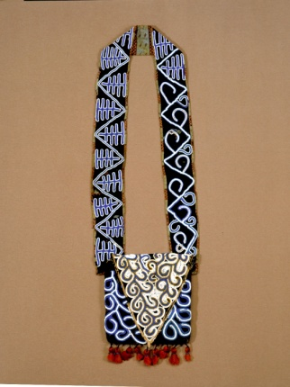
Creek Peoples, Alabama, Georgia or Florida, United States, Bandolier Bag, ca. 1830 Wool stroud, glass beads, cotton cloth, wool thread Museum purchase: Carrie Heidrich and George S. Frierson, Jr. Funds in honor of Mercedes and Dr. Thomas St. Germain Whitecloud III and Gift of I.S.K. Reeves V, and Sara W. Reeves, 2005.39
Chippewa Peoples, United States or Canada, Bandolier Bag, ca. 1830 Wool stroud, glass beads, silk ribbon, cotton fabric Promised Gift of Mercedes Whitecloud
Chippewa Peoples, United States or Canada, Bandolier Bag, ca. 1860 Wool yarn, wool tape, wool stroud, glass beads, thread Promised Gift of Mercedes Whitecloud
Bandolier or shoulder bags are believed to have been inspired by the shot pouches carried by European soldiers. These prestige objects were very popular in the nineteenth century in the Southeast and Great Lakes regions. Southeastern bandolier bags have triangular flaps that cover the opening. The Creek bandolier bag at the right contained lead shot and vegetal material in the pouch when it was purchased, indicating that it was a functional and ceremonial accessory. The black bandolier bag in the center is the same size as the Creek bag, although made almost a thousand miles apart. Instead of creating a triangular flap, the Chippewa maker inverted the bottom of the flap, perhaps to distinguish it from the Southeastern design. The large pouch and wide straps of the Chippewa bandolier bag on the left is an example of the increased size commonly seen through the second half of the nineteenth century. Unique to this bag is its combination of of both finger-weaving and loom-weaving. The body is made of wool yarn strung through glass seed beads; the careful tight designs represent animal tracks. The beaded strap has been loom-woven and was likely made later, as a replacement for the original strap.
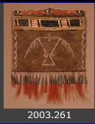
Possibly Chippewa Peoples, United States, Great Lakes Region, Pouch, late 18th century Brown dyed buckskin, dyed and natural porcupine quills, dyed deer hair, metal cones Gift of Mercedes Whitecloud in memory of Dr. Thomas St. Germain Whitecloud III, 2003.261
Possibly Ottawa Peoples, United States, Eastern Great Lakes Region, Knife Sheath, late 18th century Buckskin, dyed and natural porcupine quills Gift of Mercedes Whitecloud in memory of Dr. Thomas St. Germain Whitecloud III, 2013.36
This Pouch and Knife Sheath are the oldest post-contact objects in the collection. The decoration of the pouch, which is missing its strap, is made of bird and porcupine quills that form the image of a thunderbird, a powerful spirit known as a Manito in the pantheon of Great Lakes peoples. On each side are zigzags of lightning that the thunderbird creates with its eyes. The tinkling tin cones represent the falling rain. Knife sheathes were worn like necklaces; a string or piece of leather, now missing, would have passed through the small slit in the tab. The asymmetrical quilled decoration forms a zigzag design based on animal tracks on the right, and on the left are four crescent moons. Both of these objects were made from buckskin reportedly dyed in a solution made from crushed nutshells. After exposing the skin to wood smoke, a paste of mashed animal brain matter would be applied as part of a tanning process that created waterproof leather products with a delicate texture. In 1770, Anglo American artist Benjamin West completed a painting depicting the death of British General James Wolfe in a 1759 battle during the French and Indian War. This detail shows a kneeling Native American warrior, wearing a pouch over his shoulder and a knife sheath around his neck, both similar to the objects displayed here.

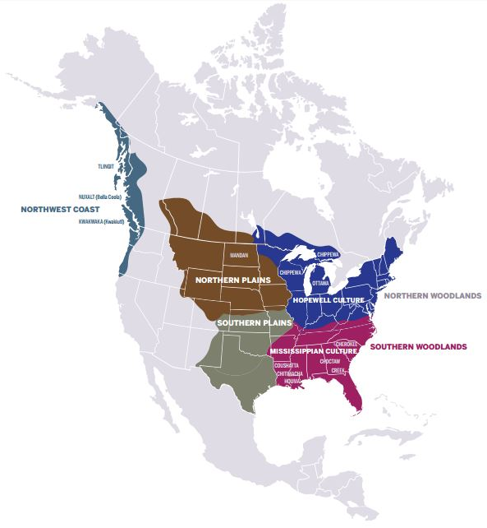
The Arts of the First Americans
The installation in this gallery presents the traditional arts of indigenous cultures from three regions of the North American continent: the Great Plains, the Northwest Coast, and the southern and northern Woodlands, spanning 1,500 years from the pre-contact period (before the arrival of Europeans) to contemporary times. On view are objects made by the Mandan, Kwakwakw (Kwakiutl), Tlingit, Nuxalt, Choctaw, Chippewa and Creek peoples. There are also objects from the Mississippian and Hopewell cultures and a display of exceptional Louisiana baskets made by the Chitimacha, Choctaw, Houma and Coushatta peoples.

The ancestors of the people now referred to as Native Americans first arrived on this continent approximately 15,000 years ago; the first humans to inhabit the Americas. Over time people settled in different geographic areas and developed distinctive material cultures that reflected their ecosystems. Each region was home to multiple tribes that spoke a variety of languages. What we know of the art of these first Americans is limited to excavated objects made of materials that do not decay. Additional information comes from objects collected by early European traders and explorers who bartered for treasured objects from the peoples they encountered.

In the early contact years, during the sixteenth and seventeenth centuries, some pre-contact objects constructed from organic materials were collected and preserved. From these rare objects we know that there was a vibrant tradition of painting and decorating objects made of animal hide, and of painting, carving and sculpting wood objects. The artists, usually women, created designs that reflected her environment and served the ritual and everyday needs of her community. After the contact period, new materials became available through trade; glass beads, printed cloth, wool and silk from Europe became popular with native artists. The introduction of these new materials did not change the Native American aesthetic; rather these materials were incorporated into forms and designs that reflected ancient traditions and beliefs.

