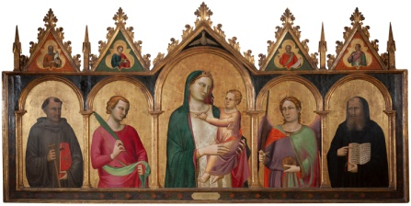

Follower of Bernardo Daddi (Italian, Florentine, 1312-1348), Madonna and Child with Saints, c 1340, Tempera and gold leaf on linden wood, Gift of The Samuel H. Kress Collection, 61.60

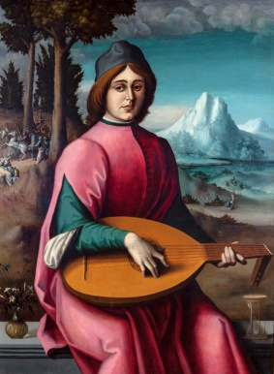

Francesco d’Ubertino, called Bacchiacca (Italian, Florentine, 1494 – 1557), Portrait of a Young Lute Player, c. 1524 – 25, Oil on poplar wood, The Samuel H. Kress Collection, 61.75
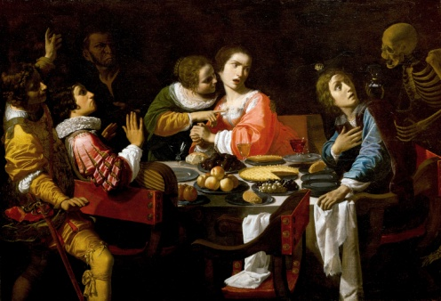

Memento Mori (Death Comes to the Dinner Table), c. 1650, Giovanni Martinelli (Italian, Florentine, 1610 – 1639), Oil on canvas, Gift of Mrs. G. Helis, Sr. in memory of her husband, 56.57

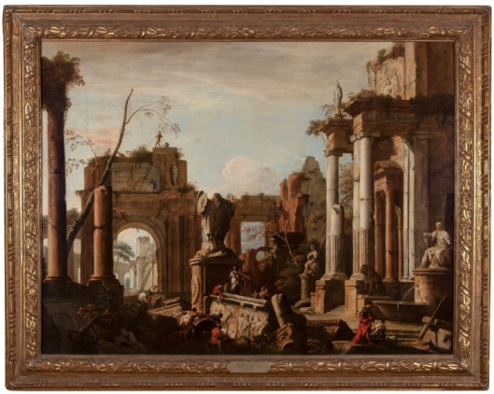

Sebastiano Ricci (Italian, Venetian, 1659 – 1734) and Marco Ricci (Italian, Venetian, 1676 –1730), Imaginary Scene with Ruins and Figures, c. 1725, Oil on canvas, The Samual H. Kress Collection, 61.85

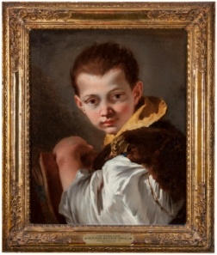

Boy Holding a Book (Portrait of Lorenzo Tiepolo), ca. 1747 - 1750, oil on canvas, Giovanni Battista Tiepolo (or studio), The Samuel H. Kress Collection, 61.87

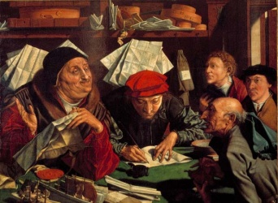

Marinus van Reymerswaele (Claeszon), (Flemish, 1495 – 1566), The Lawyer’s Office, 1545, Oil on wood, Ella West Freeman Foundation Matching Fund, 70.7

Bartholomeus van der Helst (Dutch, 1613 – 1670), Homo Bullo: A Boy Blowing Bubbles in a Landscape, c. 1665, Oil on canvas, Museum purchase, The Edith and Rosenwald Stern Fund, 95.189

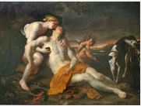

Thomas Willeboirts-Bosschaert (Belgian, 1613 – 1654), Venus Mourning the Death of Adonis, N.D.

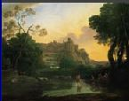

Claude Lorraine (French, 1600 - 1682), Ideal View of Tivoli, 1644, Oil on canvas, Museum purchase, Art Acquisition Fund Drive, 78.1
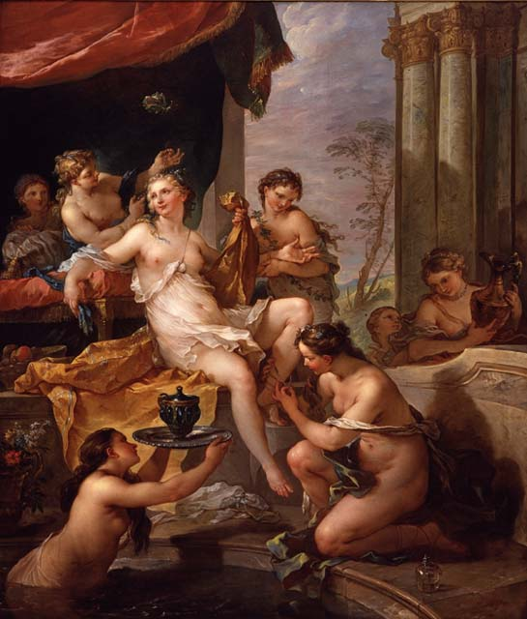

The Toilette of Psyche, 1735 – 36, Charles Joseph Natoire (French, 1700 – 1777), Oil on canvas, Museum purchase with the bequest of Judge Charles E. Claiborne, 40.2

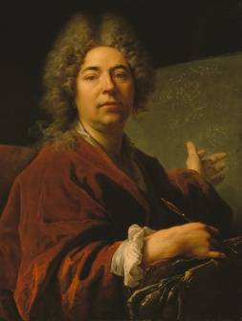

Self Portrait, 1711, Nicolas de Largillière (French, 1656-1746), Oil on canvas, Women’s Volunteer Committee Fund, in memory of Frederick M. Stafford, 82.164

[Type a quote from the document or the summary of an interesting point. You can position the text box anywhere in the document. Use the Text Box Tools tab to change the formatting of the pull quote text box.]

