Louisiana Indians Walking Along a Bayou, 1847, Alfred Boisseau (American/French, 1823-1901), Oil on canvas, Gift of William E. Groves, 56.34

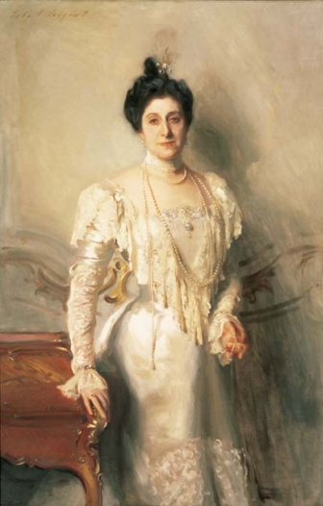

Portrait of Mrs. Asher B. Wertheimer, 1898, John Singer Sargent (American, 1856-1925), Oil on canvas, Museum purchase in memory of William H. Henderson, 78.3
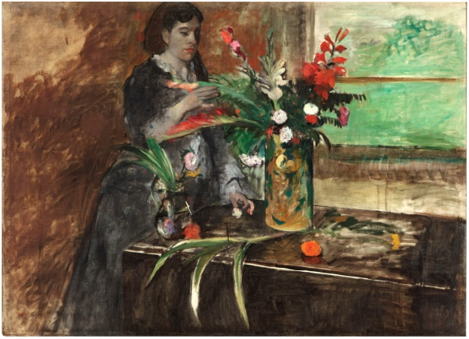
Portrait of Estelle Musson Degas, 1872, Edgar Degas (French, 1834-1917), Oil on canvas, Museum Purchase through Public Subscription, 65.1

Bather III, 1916-1917, cast 1941, Jacques Lipchitz (American, born in Lithuania, 1891–1973), Bronze with gold patina, Gift of an anonymous donor through the American Federation of Arts, 60.38

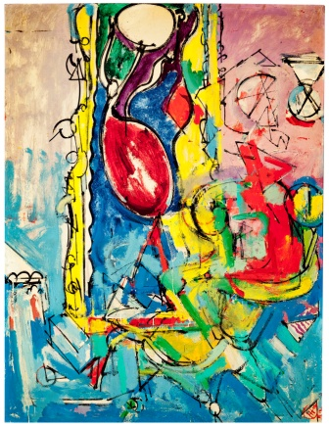

Abstraction of Chair and Miró, 1943,
Hans Hofmann (American/German, 1880-1966), Oil on canvas, Gift of the Muriel Bultman Francis Collection, 86.200.a

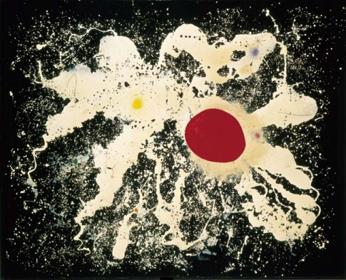

The Red Disc, 1960, Joan Miro (Spanish, 1893 – 1983), oil on canvas, Bequest of Victor K. Kiam, 77.296

