Taylor Scholars Awards Program
E-mail: taylorawards@bellsouth.net

February 11, 2016

Respond by April 11 and reward your best students with FREE memberships to Louisiana attractions!

Dear Superintendent,

It’s time to once again recognize your outstanding students! Audubon Nature Institute and the New Orleans Museum of Art (NOMA), in partnership with the Patrick F. Taylor Foundation, are rewarding your best and brightest with free annual memberships through the Taylor Scholars Awards Program!

Thanks to the involvement of schools across Louisiana and more than 50 Superintendents like you, more than 196,000 students earned free memberships in 2015, the 19th year of this statewide program. With your continued participation, students in your parish will claim their reward in 2016.

Endorsed by the Board of Elementary & Secondary Education, the Taylor Scholars Awards Program rewards qualified 7-12 grade students with a certificate of achievement and free membership to four of our state’s premier learning institutions.

Program qualifications are as follows:
- Those in grades 7 – 12 earning a 2.5-2.9 GPA during the 2015-16 school year are TAYLOR STUDENTS and will receive a one-year membership to Audubon Aquarium of the Americas, Audubon Butterfly Garden and Insectarium, and the New Orleans Museum of Art.
- Those in grades 7 – 12 earning a 3.0+ GPA during the 2015-16 school year are TAYLOR SCHOLARS and will receive the same as benefits as Taylor Students – plus a one-year membership to Audubon Zoo.

To participate, please identify qualified students in your district based on GPA as described above and submit the total number of Taylor Students and the total number of Taylor Scholars for each school in your district by April 11. The enclosed information sheet may help.

A letter with this same request is also mailed directly to schools. To avoid duplication of effort, let your school principals know if you plan to send us your numbers directly.

NOTE: Due to the recent passage of Acts #677 and #837 by the Louisiana Legislature, we can no longer request names or other data about your students. Instead, this year, we ask that you submit only the number of qualifying students for each award level by school. We will ship blank membership certificates for you to personalize and distribute to students.

We need all information by APRIL 11, 2016. We suggest districts use the latest grading period (typically 3rd quarter) to meet the APRIL 11 deadline.

We look forward to working with you to recognize outstanding students! Learn more by visiting AudubonInstitute.org/members/taylor or NOMA.org. Or, contact us at taylorawards@bellsouth.net or (504) 889-8882.

Thank you in advance for your support!

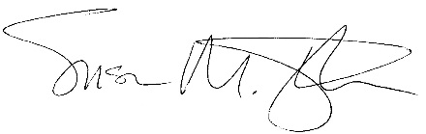
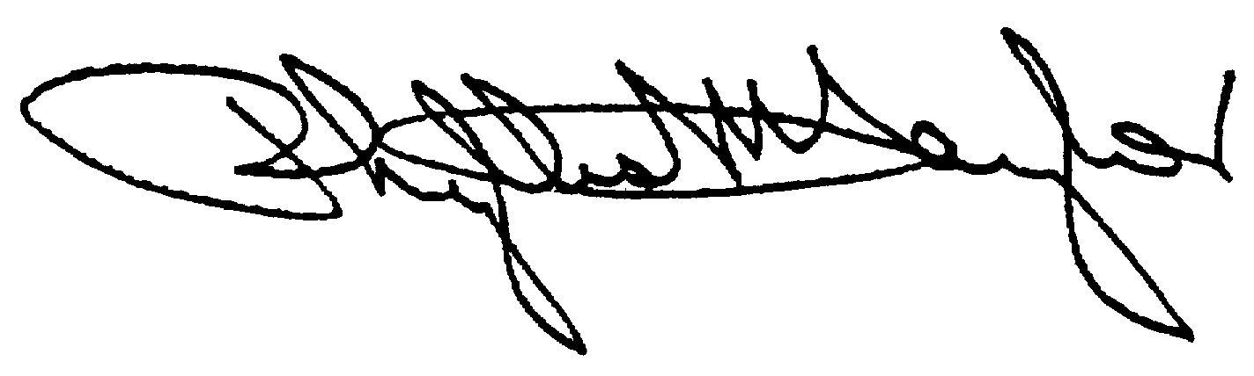
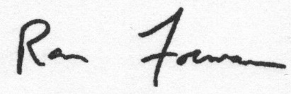

Phyllis M. Taylor Ron Forman Susan M. Taylor
Chairman and President President & CEO The Montine McDaniel Freeman Director
Patrick F. Taylor Foundation Audubon Nature Institute New Orleans Museum of Art

P.S. Last year, over 50 Parish Superintendents provided lists of their qualifying students. Please e-mail us at taylorawards@bellsouth.net with your commitment to participate today!

